LAB 2 Assignment: User Experience & Design Analysis — Tata 1mg
1. Empathy Map — Tata 1mg
User: Senior Citizen
Goal: Purchase necessary prescription drugs conveniently and cost-effectively through secure and prompt home delivery.

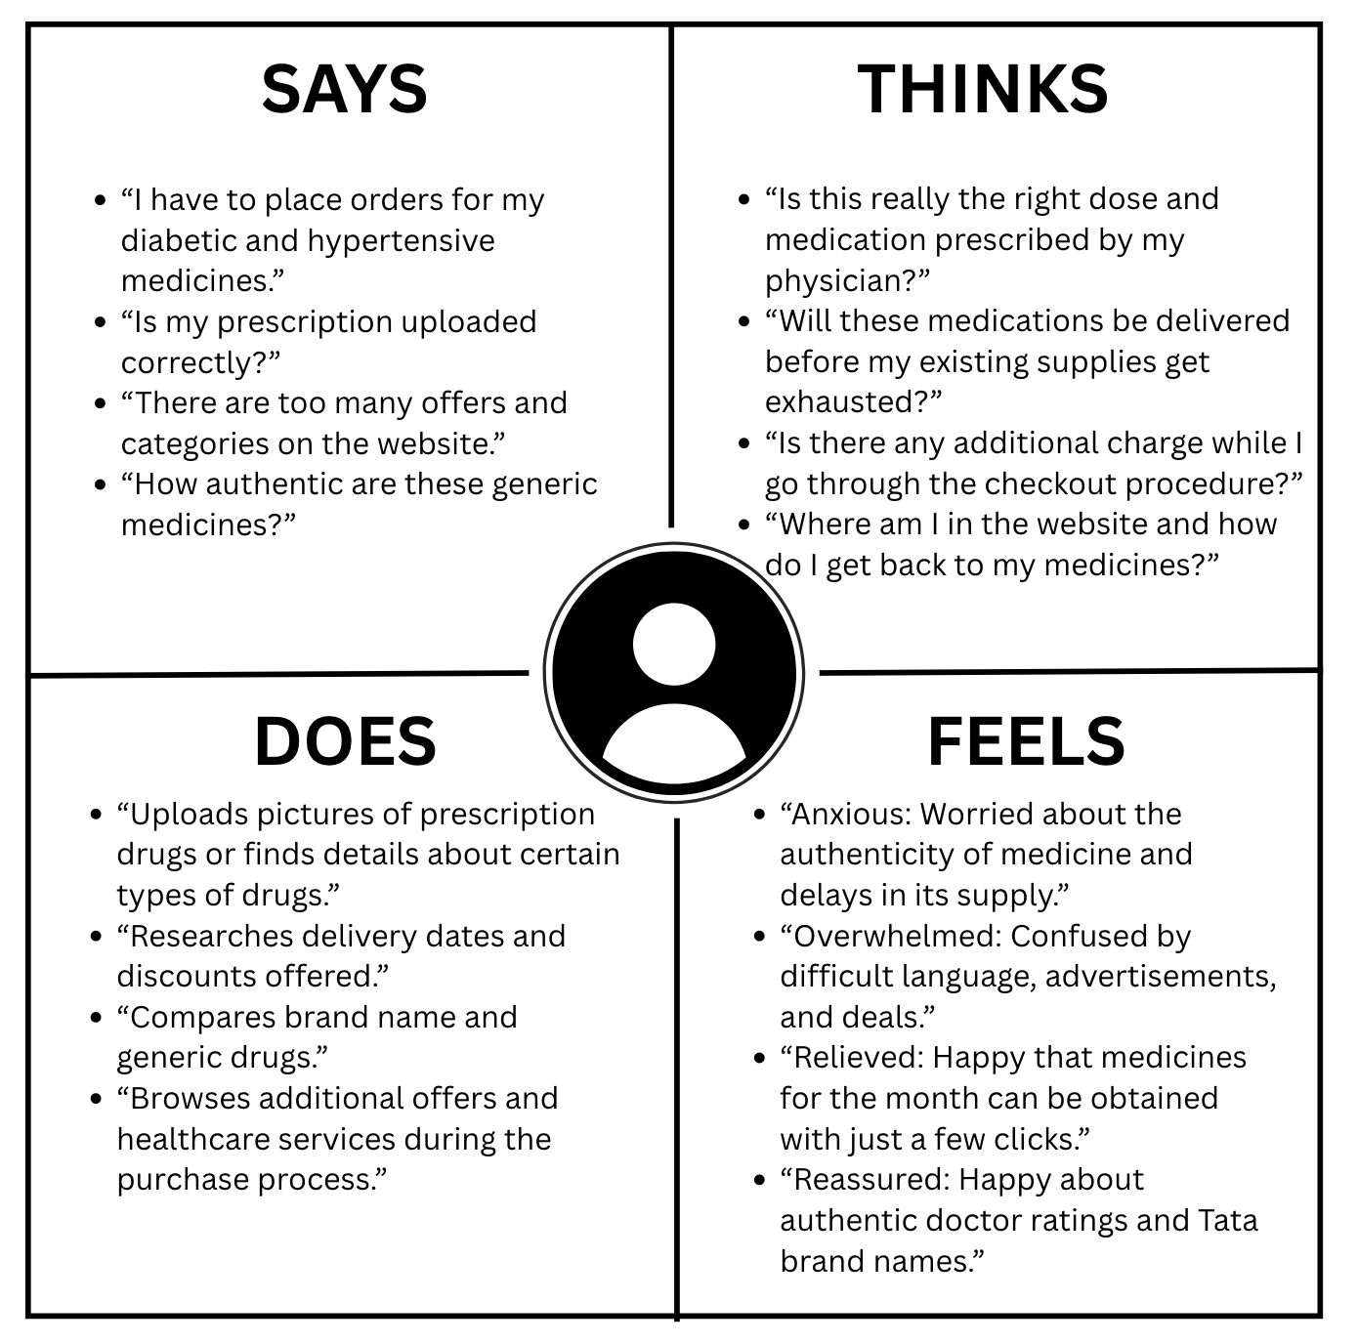
Main Insight:
Tata 1mg provides convenient access to medicines and healthcare services, but the large amount of information, promotional content, and multiple navigation options can overwhelm users, especially senior citizens who need a simple and focused purchasing experience.

2. Pain Points — Tata 1mg
1. Interruptions in the Checkout Process
Pop-ups and upsell offers interrupt the purchase process, such as promoting health packages, samples or memberships when the user is trying to complete an order.

2. Overcrowded Homepage
The homepage contains many banners, categories, offers and healthcare services, making it difficult to focus on the main task.

3. Complex Navigation
There are many sections and subcategories, and the navigation changes across different pages, making it difficult to know where to go or how to return.

4. Alternatives Require Manual Comparison
Tata 1mg provides substitute medicines with information such as price, marketer and savings, but users have to compare the alternatives one by one instead of seeing the key differences together.

5. Unclear Prescription Status
After uploading a prescription, it is not always clear to the user whether it has been received, is being reviewed or has been approved.

6. Unclear Delivery Expectations
Users can face uncertainty when the estimated delivery information changes during different stages of the ordering process.

7. Reordering Regular Medicines
Users who purchase the same medicines regularly have to repeat much of the ordering process instead of having a simple dedicated refill experience.
Key Pain Point:
“I want to quickly find and order my prescribed medicines, but the complex navigation, crowded interface and checkout interruptions make the process confusing and frustrating.”
3. User Journey Map — Tata 1mg
Persona: Ramesh Verma (Elderly User)
Goal: Reorder monthly chronic medications smoothly.

Stage | Action 1: Open Website | Action 2: Search Medicine | Action 3: Select Item & Review Salt | Action 4: Upload Prescription & Checkout | Action 5: Track Order & Receive
Task List | A. Open Tata 1mg  B. Set delivery pin code  C. Browse homepage | A. Search medicine name  B. Browse results  C. Apply filters | A. Select correct medicine  B. Check details and alternatives  C. Add to cart | A. Upload prescription  B. Select address  C. Complete payment | A. Check order status  B. Receive package  C. Verify medicines
Feeling | Cautious, hopeful | Focused, slightly overwhelmed | Careful, attentive | Anxious, cautious | Relieved, satisfied
Adjective | Confused by the ads and number of options | Overwhelmed by results | Careful while checking medicine details | Annoyed by checkout interruptions | Reassured when delivery is on time
Improvement Opportunities | Simplify home screen to highlight search & refill. | Improve filtering and make important medicine results easier to identify. | Make alternatives easier to compare and present key differences clearly. | Remove pop-ups & provide clearer prescription status. | Provide accurate step-by-step dispatch updates.

4. Persona — Tata 1mg
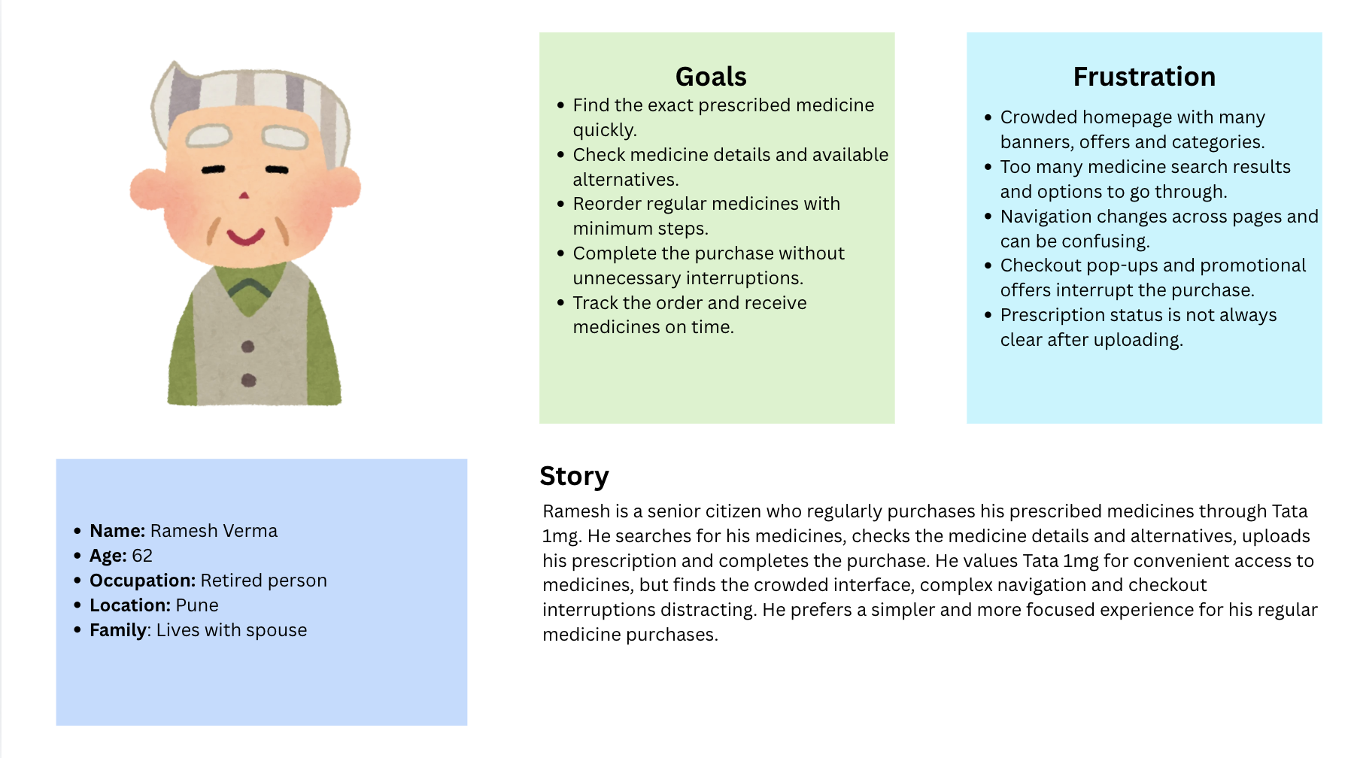
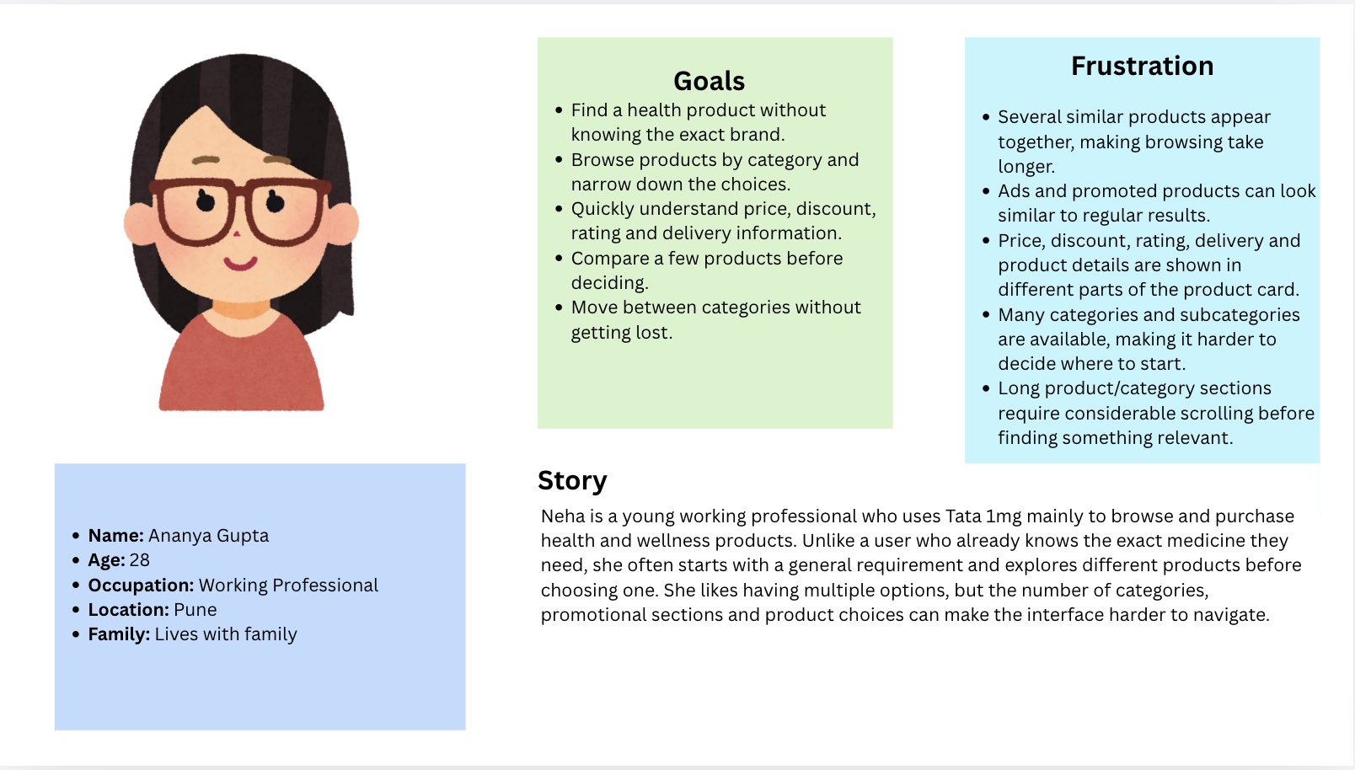
5. Gaps & Future Improvements
Current Gap | Future Improvement
Overcrowded Homepage Layout | Introduce a cleaner homepage layout with fewer competing banners and clearer priority for important actions.Can introduce minimalist mode/senior-friendly mode.
Interruptions | Replace promotional pop-ups with non-intrusive suggestions.
Complex Navigation | Use a consistent navigation structure across pages so users can easily understand where they are and move between sections.
Overwhelming Medicine Search | Improve filters and search results so users can quickly narrow down the required medicine by relevant details such as strength, form and pack size.
Alternatives Require Manual Comparison | Add a side-by-side comparison view showing important differences between substitute medicines.
Unclear Prescription Status | Provide clear status steps such as Uploaded → Under Verification → Approved after prescription submission.
Reordering Regular Medicines | Provide a dedicated refill option that lets users quickly reorder medicines they purchase regularly,maybe a monthly refill.

5. Future Features
- 1-Click Chronic Care Refill
A dedicated refill widget showing regularly purchased medicines and allowing users to reorder them with a single tap.
- Senior Accessibility Mode
An optional mode with larger text, larger touch targets, simpler navigation and reduced promotional content.
- Smart Generic Substitute Comparison
A side-by-side comparison showing key details such as price, manufacturer, strength and savings for substitute medicines.
- Prescription Verification Tracker
A visual status tracker showing the progress of a prescription, such as Uploaded → Under Verification → Approved.
- Auto-Apply Best Coupon
Automatically apply the most suitable available coupon during checkout instead of making users search for and enter coupon codes.
- Medicine Reminder & Refill Tracker
A dashboard that helps users track regular medicines, upcoming doses and when a refill may be needed.

